
Cold Weather
Safety
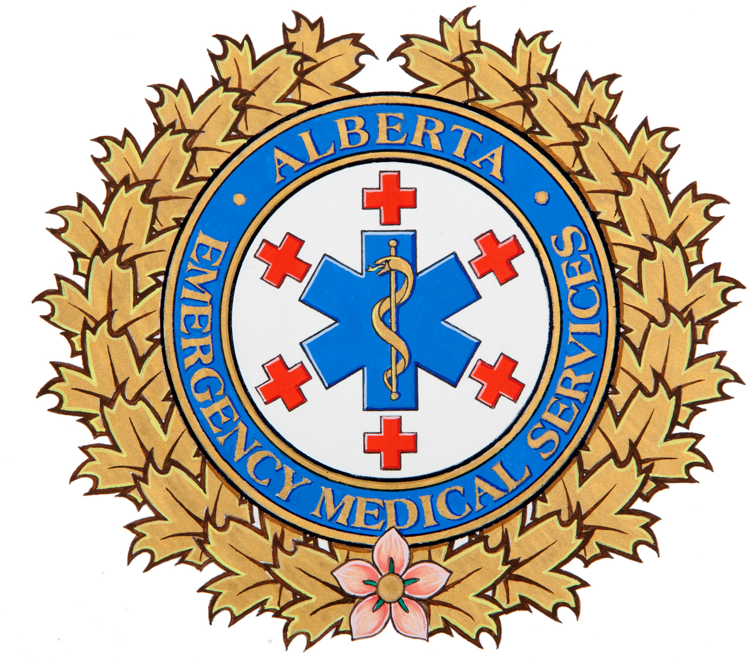

Alberta Health Services EMS responds to many cold weather related emergencies every winter. However, by taking appropriate measures to dress properly, anticipate sudden weather changes, and be prepared when out in the cold you can reduce your risk of sustaining a cold weather emergency. It’s also advised you store an emergency kit in your vehicle at all times containing extra clothing, blankets, and other road-side supplies.

Frostnip
- Frost-nipped skin is extremely cold, but not yet frozen skin.
- It commonly affects the ears, nose, cheeks, fingers and toes;
- The skin may look red and possibly feel numb to the touch;
- When treated promptly, frostnip heals without complication;
- Move to a warm environment and immediately, but gently re-warm the affected area through skin to skin contact (i.e. hand covering tips of ears).
Frostbite
- Frostbite occurs when skin becomes so cold, the skin and underlying tissues freeze solid;
- Affected skin may look white and waxy and will feel hard to the touch;
- Move to a warm environment immediately and place the affected area in warm, not hot, water, until fully re-warmed;
- Call 9-1-1- or seek further medical attention as required.

Hypothermia

- Hypothermia is abnormally low body temperature, less than 34°C (as compared to normal body temperature of about 37°C);
- Early hypothermia may manifest as profound shivering; moderate hypothermic patients may act inappropriately: stumbling, mumbling, and fumbling, as their body temperature continues to drop resulting in severe hypothermia (<30°C);
- Left untreated, severe hypothermia may progress to unconsciousness or death;
- Early recognition and prompt medical attention is crucial.Call 9-1-1. Don’t forget to protect yourself from the factors that originally lead to the patient’s situation;
- Initiate gentle re-warming as quickly as possible. Remove any wet or constrictive clothing; cover with blankets, or sleeping bags. Protect from further heat loss: eliminate contact with cold surfaces, and shield from wind and moisture.

